Welcome to STARS!

Your school has been set up on the STARS system and you now have access to your online profile. It’s a good idea to get yourself familiar with the STARS website. If you find yourself stuck at any point you can contact one of the Active Travel team by emailing - schooltravelplans@suffolk.gov.uk.
There are a few steps to follow to get you on your way to your first award. Again, if you have any issues completing any of the steps below, a member of the Active Travel team will be happy to help.

GREEN Award

There is a checklist of things to complete to receive each award. Below is the checklist for your Green Award.
- Introduction
- Aims & Objectives
- Travel & Transport Infrastructure
- Targets (x2)
- Consultations (2 Planned)
- Travel Initiatives (10 Planned)
- Supporting Initiatives (5 Planned)

You can check your progress at any point by clicking on Accreditation tab at the top of your profile.

Introduction
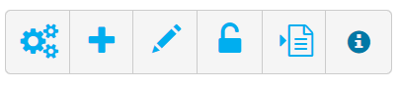
Click on the Introduction tab along the top o your profile. There should be a pencil icon in the top right corner, by clicking on this you will be able to edit and fill out the details. There may be some boxes you are unable to fill but at minimum Travel Plan Coordinator; Site email; Introduction to Site; Local Amenities; Student Start & Finish Times and Age range of students should be completed.

It is important that anyone reading the plan can understand how to get to the site, what to expect when they arrive as well as what the school has done in terms of initiatives, etc.

Aims & Objectives
It’s time to have a think about your schools aims and objectives when it comes to active and sustainable travel. A simple sentence or two is enough. If you are stuck, below are some examples to help give you inspiration.
Aims -
- To promote road safety, being healthy and doing our bit to reduce our carbon footprint
- To encourage sustainable travel to and from school by parents. This in turn will improve road safety and parking issues as well as air quality for both the school and community.
- To reduce the Carbon Footprint of the School and its users and to promote a healthy way to travel to and from school.
Objectives -
- To increase health and wellbeing and increase activity, reduce traffic close to school, and increase safety for road /non-road users in and around our school community, while also thinking about our environment.
- To improve road safety amongst the children and their families. Improve awareness of road safety amongst our parent body.
- To increase health and wellbeing across the school and reduce traffic levels to increase the safety of school users.
Adding Aims & Objectives works the same way as mentioned above. Select the relevant tab and then click on the pencil icon to edit.

Travel & Transport Infrastructure
Select the relevant tab and click the pencil icon to edit. Evey box on this page must be filled out, even if that means entering “0” into some boxes.*
*Engineering & Planning Measures may not be relevant to your school. If this is the case, you do not have to fill out this section.
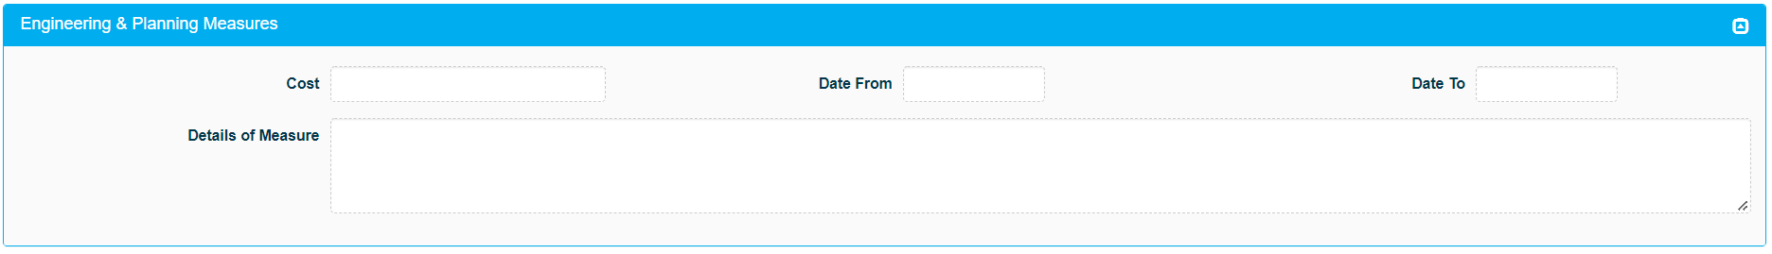

Targets
You are required to set two targets on behalf of your school. You can choose if these targets are aimed at students or staff and which mode of travel they focus on (walking, cycling ect).
Some example of targets are:
- “Work towards 60% of children walking to school on a regular basis.”
- “Work towards 30% less cars in our staff car park.”

To add a target make sure you are on the Site tab. In the top right corner is a cog icon, click on this and then selct ‘Add New Target’.
Below is how it would look to enter the first example on your profile.
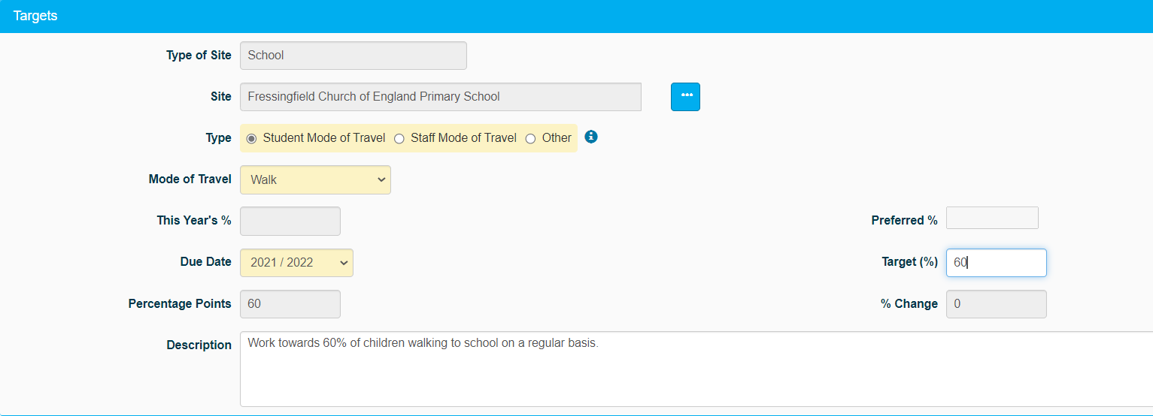

Consultations and Initiatives
You’re almost ready to start working towards your first award. The final step is to add your chosen consultations and initiatives. Hopefully you have an idea of what it is your school will be working towards. If you don’t, the Active Travel team can help you with this (chances are you are already completing certain initiatives without even trying!).
You should have a list of all the Modeshift consultations and initiatives. If you do not have a copy of this, please ask the Active Travel Team who will send you one. Initiatives are broken into two categories Travel and Supporting. You need to select 10 Travel and 2 Supporting initiatives as well as 2 consultations.
At this stage you are just planning to complete these, you do not have to have actually done the things you are selecting. However, when you work towards your Bronze award, you will need to show evidence of completing all of the ones you select. With this in mind, make sure the initiatives you set are achievable and something you can provide evidence for.
To add your initiatives, select the Site tab then the cogs. Select ‘Add New Consultation / Add New Initiative’. This will open a new window where you can fill out the relevant information.
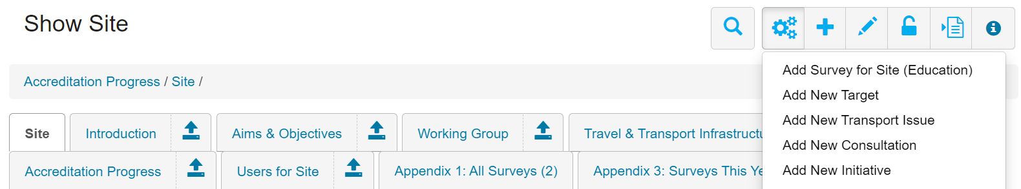

IMPORTATNT!
Make sure you hit save after editing anything if not any changes made will be lost.

